7. Joining multiple tables using various types of joins (Inner join, Outer join).

Create Table 1
create table employee(
id int primary key,
name varchar(100),
department_id int
);
insert into employee(id,name,department_id)values
(1,'hisha',101),
(2,'siya',102),
(3,'diya',103),
(4,'priya',null);
select*from employee;
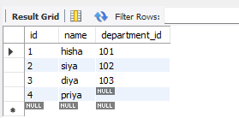

Create Table 2
create table departments(
id int primary key,
dept_name varchar(100)
);
select*from departments;
insert into departments (id,dept_name)values
(101,'hr'),
(102,'it'),
(104,'finance');
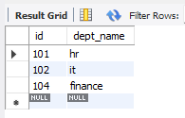

INNER JOIN
select e.id,e.name,d.dept_name
from employee e
inner join departments d on e.department_id=d.id;


OUTER JOIN
select e.id,e.name,d.dept_name
from employee e
left join departments d on e.department_id=d.id
union
select e.id,e.name,d.dept_name
from employee e
right join departments d on e.department_id=d.id;

